Lecture 9.
Self-assembling systems. Mono- and polymolecular layers of surfactants. Thin films.

Methods and mechanisms of self-assembling nanosystems formation, peculiarities of the processes, the properties of the systems obtained were studied in areas of Colloidal Chemistry for many years. Generally, they are systems obtained spontaneously by the bottom-up approach (Lecture 3).

The following systems relate to self-assembling nanosystems:
- clusters;
- adsorption layers of surface-active agents (surfactants);
- periodic and “island” colloidal structures;
- direct and reverse micelles;
- microemulsions.

Clusters are systems of a large number of bonded atoms and molecules. If clusters contain the ions that such bonds might be significant. Under these conditions the intermolecular (Van der Waals) interactions within the cluster increases and the interfacial boundary between cluster and medium forms, i.e., there are the formation of nanoparticles as a dispersed phase of the dispersed system.
Colloidal clusters are formed in solutions and have sizes up to 100 nm. They exist in a liquid phase and they do not coagulate. In relation to the liquid phase the colloidal clusters can be divided into 2 groups: lyophilic (hydrophilic) and lyophobic (hydrophobic). Lyophilic clusters are capable to adsorb the molecules of the medium on their surface (e.g., water) and form a strong solvate layers. Typical representatives of hydrophilic clusters are oxides of silicon, iron and other metals. As an example of lyophilic cluster preparation, the hydrolysis reaction of inorganic metal salts can be given:

FeCl₃ + 3H₂O $↔$ Fe(OH)₃ + 3HCl

and the reaction leading to the formation of gold sol:

2HAuCl₄ + 3H₂O $→$ 2Au + 8HCl + 1,5O₂

It is possible to obtain the nanoparticle of clusters by sedimentation onto a substrate, in particular, by gas-phase method in a vacuum. Porous films of nanoparticles are formed as a result of the process of cluster accumulation.
Nanosystems based on surfactants are formed spontaneously also. It is known that the surfactant molecules have diphilic (amphiphilic) structure (Fig. 1)

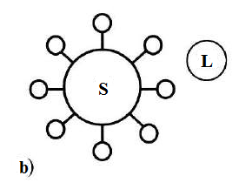
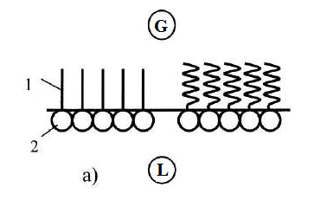

Figure 1 – Adsorption layers of surfactants at the interface of L/G (a) and on the surface of the particle S/L (b)

The long part of the molecule (1) is a hydrocarbon radical. This radical is non-polar and hydrophobic; it has no affinity to water. The other part of the surfactant molecules, usually smaller, contains a hydrophilic polar group (2) which has an affinity to water. Schematically, the surfactant molecule is depicted as circles (hydrophilic polar group, “hydrophilic head”) and line (hydrophobic non-polar group, “hydrophobic tail”). The groups with significant affinity to water can serve as hydrophilic part of the surfactant molecules: -COOH -ОН, -СНО, -NH₂, -SH, -CNS, -SO₂H, -CN, -NO, etc.
The sodium salt of stearic acid is a surfactant which enters into composition of a soap. But unlike valeric acid which hardly dissociates in water and does not form ions, sodium stearate dissociates in an aqueous solution, forming a surface-active anion:

C₁₇H₃₅COONa => C₁₇H₃₅COO⁻ + Na⁺

anion C₁₇H₃₅COO⁻ has a long hydrocarbon radical.

Due to the diphilic structure, surfactant molecules adsorbes at the interface of water – air (Fig. 33, а). The hydrophilic part of the molecules with affinity to the polar water molecules interact with water and nonpolar hydrophobic part is pushed in a non-polar phase (air).
The maximum adsorption is achieved at a particular concentration of the surfactant solution (Fig. 33, а) and nanolayer of surfactant spontaneously forms.
The adsorption of the surfactant on the surface contradicts to the laws of diffusion, since the spontaneous process does not proceed from a higher concentration to a lower one, but, on the contrary, from a lower concentration (surfactant in solution) to a larger one (surfactant on the surface).
It should be noted that similar process for the surfactants is determined by the entropy (S). Entropy is one of the thermodynamic functions of the state. It is a characteristic of a spontaneous process.
At the adsorption of surfactants on the surface two processes of entropy change of surfactants and water are observed. In the case of surfactant adsorption, the process goes from disorder (surfactant in water) to order on the surface (Fig. 33, а), and entropy decreases, ∆S < 0. Decreasing of surfactant concentration in water due to adsorption restores interrupted disorder in water, i.e. the process goes from order to disorder, entropy increases, ∆S > 0, and the second process prevails.
For this reason, the entropy of the surfactant adsorption process increases and leads to the spontaneous transition of surfactant from solution on the surface. Adsorption layers of surfactants at the interface forms one-dimensional nanosized structures (Fig. 33, а) or thin films of surfactants.
Structural-mechanical barrier preventing the coagulation of nanoparticles is formed due to the adsorption layer of surfactant.
Self-organization is possible by means of the local concentrating of surfactant molecules with the formation of “island” nanoscale structures. Often such structures (in the form of meniscus) occur near the line of three-phase contact. The essence of the “island” structures is the uneven distribution of the surfactant in the adsorption layer, their high concentration in this layer, that causes the formation of singular micelles.
The formation of structures from surfactant molecules can be carried out by Langmuir - Blodgett technique (Fig. 2). The adsorption layers of insoluble surfactants can be transferred from the air-solution interface onto the solid substrate, forming the so-called Langmuir-Blodgett films.
The deposition of adsorption layers takes place on a slide that moves perpendicular to the air – solution interface containing the adsorption layer. Film transfer usually occurs at constant and rather high value of the two-dimensional pressure (Fig. 3).

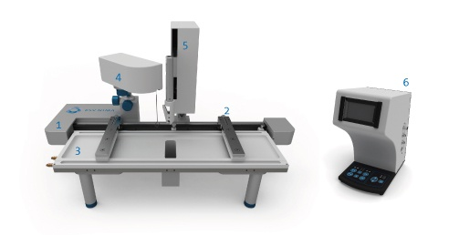
1 – Frame, 2 – Barriers, 3– Trough top, 4– Surface pressure sensor, 5– Dipping mechanism (Langmuir-Blodgett option), 6 – Interface unit

Figure 2 – The components of Langmuir-Blodgett trough

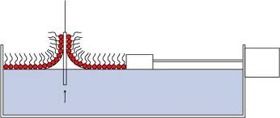

Figure 3– The deposition of surfactant adsorption layers on a slide

The method consists of transferring the condensed films from the surface of the liquid to the surface of slides of metal, glass and other materials. "Direct" (Fig. 4 a, by the hydrophilic part of the surfactant molecules) or "reverse" (Fig. 4 b, by hydrophobic part) orientations on solid surface and hydrophilization or hydrophobization of the surface, respectively, depends on the position of the surfactant.

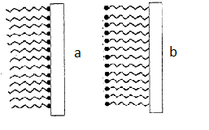
Figure 4 – a) - Hydrophilization and b) - hydrophobization of the surface by Langmuir – Blodgett technique

If the slide is moved by turns in both upward and downward directions, polymolecular films is formed (Fig.5).
In these films the neighboring monolayers alternately come into contact with their hydrocarbon chains and polar groups, as shown in Fig. 5, b. If the slide always moves into one direction, the "polar" films (with uncompensated dipole moment of surfactant molecules in the neighboring monolayers) may be formed. In such layers the polar groups of one monolayer come into contact with hydrocarbon chains of the other. If the slide is hydrophobic, and moves in the downward direction, the X-type films are formed (Fig. 5, a). The deposition on a hydrophilic slide moving in the upward direction results in the formation of Z-type films (Fig. 5, c).
The Langmuir-Blodgett technique allows one to form structures with the predetermined molecular arrangement, in which the neighboring monolayers have the desired composition. For example, by using water insoluble organic acids with sufficiently long chain length, such as stearic, the composition of deposited layers can be modified by changing the electrolyte content of the substrate solution by introducing polyvalent ions that form insoluble salts with the acids.

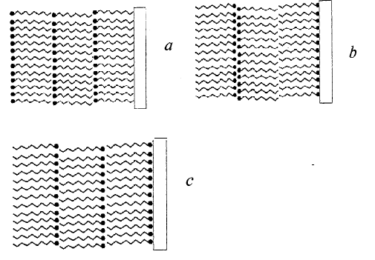
a) – X-type, b) – Y-type c) – Z-type films
Figure 5 – Different types of Langmuir-Blodgett films deposited on a solid surface

The method of the Langmuir - Blodgett is quite widespread for obtaining self-organized nanoparticles at interfaces. An ordered monolayer of nanoparticles can be formed on vertical surfaces by removing the slide from the colloidal solution and after evaporation of the solvent. Hydrophobic nanoparticles can be formed at the interface air - water and then transferred on a solid substrate.
Using the method of Langmuir - Blodgett allows to change the size and shape of nanoparticles from several tens to hundreds nanometers and form various structures of nanosized films.
Ordered structures can be transferred from the surface of the liquid on the solid substrate without noticeable disruption of the crystalline structure of the nanolayer. Various additives are used to impart strength to the nanolayer. In addition, a layer-by-layer assembly of nanoparticle layers is possible , that allows to create the various structures of nanolayers.
Among the perspective applications of Langmuir – Blodgett method one can name their use as monochromators and analyzers of soft long wave X-ray and neutron radiation and for synthesis of light-transmitting, electrically conducting thin films on the surfaces of solids utilized in novel electronic devices.

Revision questions:

- What are self-assembling systems?
- Give the examples of self-assembling colloidal systems?
- What are colloidal clusters? Give the examples.
- What self-assembling structures based on surfactants do you know?
- Explain the amphiphilic structure of surfactants.
- How does change the entropy of surfactant adsorption process?
- What is the Langmuir – Blodgett technique?
- Describe the Langmuir – Blodgett films.

